**New Estimates of Intergenerational Public**

**Transfers for Brazil: 1996-2011**[1]

Cassio M. Turra (corresponding author)

Department of Demography/CEDEPLAR

Federal university of Minas Gerais (UFMG)

Belo Horizonte, Brazil

e-mail: turra@cedeplar.ufmg.br

Bernardo L. Queiroz

Department of Demography/CEDEPLAR

Federal university of Minas Gerais (UFMG)

Belo Horizonte, Brazil

e-mail: lanza@cedeplar.ufmg.br

Andrew Mason  
Department of Economics

University of Hawaii at Manoa, and

East-West Center

2424 Maile Way, Saunders 542

Honolulu, HI 96821

e-mail: amason@hawaii.edu

December 8, 2015

**1. Introduction**

Not so long ago, studies underemphasized the importance of intergenerational public transfers in Brazil. Influenced by the high levels of inequality, most of the literature focused on the distribution of public resources across socioeconomic groups and geographic regions (Lavinas & Garson, 2003; Camargo, 2004; Camargo, 2003; Barrientos, et.al, 2013; Lavinas, 2007). There is now strong evidence that transfers between generations in Brazil are important for the economy and the well-being of families, particularly in a context of rapid demographic changes (Turra, Queiroz and Rios-Neto, 2011). In addition to that, we already know that Brazil has a distinct pattern of public age reallocations compared to other countries. Early analyses indicated that public transfers to the elderly strongly dominate transfers to other age groups and have been relatively more important in Brazil than elsewhere, including wealthier and smaller economies (Turra 2000; Turra and Queiroz 2005; Turra et al. 2011).

There are several competing explanations for the distinct Brazilian pattern of intergenerational public transfers (Turra et al., 2011; Aurelino and Draibe, 1989; Filguera, 2005). Elsewhere, we have argued (Turra et al. 2011) that it probably reflects the way Brazil expanded its social welfare system, particularly after the 1980s, as a response to the model of economic development adopted during most of the 20th century. Until the promulgation of the new constitution in 1988, social protection was generally limited to urban salaried workers, and excluded children and other population subgroups. The new constitution brought the so much awaited massive investments in public education and public health. However, it also implied a simultaneous vast expansion of social security to all retired workers, including those who were unable to accumulate human capital and savings over their lives because of decades of economic exclusion, and therefore, who were at high risk of becoming poor at older ages.

In the last 20 years, since the 1988 Constitution, social expenditures in Brazil have been increasing irrespective of the government in office. In 2011/2012, social expenditures represented around 23% of GDP. The 1990s witnessed the development of policies focusing on elderly poverty (rural pensions and non-contributory pension benefits), and the expansion of both the universal public health system (SUS) and the basic educational system. The 2000s are marked by an increase in the investment in reducing child poverty, especially with *Bolsa-Familia* program. Programs in recent years emphasized increase in public expenditures on secondary and tertiary educational levels. It is important to note that 1988 Constitution established a set of rules on how the social expenditures have to be made and how they should increase from one year to the other. In addition to that, it is estimated that around 90% of social expenditures in Brazil is defined by law (the Constitution) which makes it difficult to reduce them in the short-term.

In the 1990s, when the expansion of the welfare system was taking place, demographers stressed the difficulties the country would face in maintaining generous public transfers to future elderly generations in a context of rapid population aging (Wong and Carvalho, 2006; Rios-Neto, 2005) Without social security reforms and larger investments in children and youth, economic problems would be inevitable. However, Brazilians have waited too long to debate the fiscal issues of aging and to find ways to improve education quality and productivity growth in general. Whereas it is true that social security reforms involve non-trivial political costs, Brazilian society could have acted earlier to mitigate the adverse consequences that usually comes from a combination of generous public transfers to elderly, rapid demographic transition and slow productivity growth. Now, there is not much room left to avoid issues of intergenerational equity regardless of the solutions to be adopted (Turra and Queiroz, 2005b; Queiroz and Figoli, 2014)

Unfortunately, the lack of consistent yearly estimates of National Transfer Accounts, particularly public transfer inflows and outflows by age and purpose has also beset a stronger debate about the consequences of population aging in Brazil. The aforementioned studies done by Turra and colleagues under the NTA project were restricted to data from a single year, 1996, which has limited our understanding of how intergenerational public transfers have evolved over the last two decades. Although there is nothing that suggests a significant change in the distinct pattern of intergenerational public transfers in Brazil, the last twenty years have witnessed improvements in public education that might have lessened the strong bias of transfers towards the elderly that were typical in the mid-1990s.

Therefore, in this chapter, we try to fill the gap in empirical research in Brazil, by estimating public transfers on education, public health, social security for both private workers and public employees, as well as other cash and in-kind transfers using comparable data sources and methodology for the longest period possible since the promulgation of the new constitution: 1996-2011. We are interested in examining how changes in age structure and the age profiles of public transfers have affected aggregate net transfers across age groups in Brazil. In addition, we measure how resilient the pattern of public intergenerational transfers has been over the last two decades, by comparing yearly ratios of public transfers to elderly and children in Brazil with those for other NTA countries.

In the NTA project, public reallocations include both public transfers and public asset-based reallocations such as payments on public debt, public savings and capital income. Unfortunately, one shortcoming of our study is the lack of estimates for public asset-based reallocations. This limitation may affect to some extent our measures of public reallocations, but given the size of the social programs considered here and their distinctive age profiles, we believe we can still learn substantially about the role of the public sector from the evolution of intergenerational public transfers in recent years, particularly in the context of population aging. Likewise, it helps us to set the scene for the fiscal projections for Brazil that we present in the next chapters.

The rest of the chapter is organized as follows. The next section presents the data and methods used to estimate the age profiles of public transfers. Although we follow most of the NTA methodology described in UN (2013), we also apply specific strategies to overcome data limitations in Brazil. Section 3 presents estimates for all public transfers except other in-kind, because they are easier to allocate by age. Section 4 adds the results from other in-kind public transfers and section 5 presents public sector projections under alternative policy scenarios. We conclude the chapter in section 6.

**2. Estimating age profiles of public transfers**

In this chapter, we estimate net public transfers on education, health, pensions for both private workers and public employees, other cash and other in-kind, across age groups and years (1996-2011). This is done by combining individual data from household surveys with administrative records to calculate age profiles of public transfers inflows and outflows.

**Macro Controls**

First, we estimate yearly aggregate amounts (inflows) paid by purpose. In the National Transfer Accounts Project (NTA), aggregate public transfers outflows are the resources required to fund public transfer inflows. Thus, they are equal by definition. If taxes and social contributions are insufficient, less than public transfer outflows, the gap is filled through public asset-based reallocations. In principle, the gap can be funded by relying on asset income or through dis-saving, but a breakdown of public asset-based reallocations for Brazil is not provided here. Aggregate inflows on social security (private workers) come from the online historical database of the Infologo Social Welfare Statistical Yearbook from the Ministry of Social Security in Brazil (Dataprev 2015). We include all contributory and non-contributory old-age, survivor and permanent disability benefits. We exclude other social protection programs such as maternity and sickness benefits, which represent, depending on the year, about 4 to 10% of the total benefits paid by the Ministry of Social Security. We add them to the other cash public transfers, because of their distinctive age profile. We also exclude financial and capital costs, but include social security administrative expenditures.

Retirement and survivor benefits paid to public employment retirees are not accounted as public transfers in the NTA, but as deferred compensation. However, since most pensions for public servants in Brazil come from unfunded pay-as-you-go plans and represent about 4% of the GDP (more than half of the benefits paid to private workers), we chose to include them in our analysis, separating them from pensions for private workers whenever possible. We obtain yearly estimates of local, state and federal aggregate inflows from Santos et al (2014), who have reconstructed a time series of expenditures on different social protection programs using official data.

In Brazil, large intergovernmental transfers finance decentralized education and health services. Therefore, it is not straightforward to calculate consistent yearly inflows over a long period for both public programs. Nevertheless, we obtain data on inflows for public education from the National Institute for Educational Studies and Research for the years 2000 to 2011 (INEP 2015). For the earlier years, 1996 through 1999, we rely on estimates prepared by Almeida (2001). Both sources provide the aggregates by educational level, which is necessary for correctly assigning the expenditures by age. One should note that we exclude capital investment from education expenditures, since our focus is on public transfers only. Our estimates of inflows for public health are drawn from the Information System on Public Health Budgets (SIOPS) for the years 2000 to 2011 (Datasus 2015; Souza e Bittencourt 2013). Aggregate amounts for the earlier years (1996 through 1999), before the implementation of SIOPS, are available in Carvalho (2013) and are based on WHO data.

Our estimates of other cash transfers include expenditures through *Bolsa Familia*; a conditional cash transfer program that was created in 2003 and provides a monthly stipend per child attending school (to a maximum of three children) to families living in poverty, and an additional monthly flat stipend for families living in extreme poverty. *Bolsa Familia* aggregate controls come from MDS (2015). We also include expenditures with unemployment insurance and “salary bonus”(a monthly salary paid to workers earning up to minimum wages), which we draw from Ipea (2015). Finally, we add payments with social security benefits that are not typically directed to the elderly (e.g. sickness benefits), obtained from Dataprev (2015).

To measure aggregate expenditures classified in NTA as other in-kind transfers, we first obtain data on total non-financial expenses consolidated for the three spheres of governments from the Secretary of Treasury (2015) for the years 2000 to 2011. We then exclude the amounts spent on the other purposes aforementioned: pensions, education, health, and other cash transfers. Data from the Secretary of Treasury for actual payments are available only for the years 2009-2011. For earlier years, we can obtain only committed expenditures. To solve this issue and avoid overestimating other in-kind transfers, we estimate the difference between committed and actual payments for 2009 (about 9%) and adjust the amounts for the previous years by assuming the same relative difference. Data from 1996 come from earlier NTA estimates (Turra et al, 2011). For the years 1997-1999, we simply interpolate the percentage of GDP spent on other in-kind transfers between the years 1996 and 2000. Other in-kind transfers include expenditures on national defense, public safety, the judicial and legislative branches of government, culture, and the remaining federal, state and local public programs.

**Public Transfer Inflows**

Once we create a consistent set of macro controls, we assign inflows by age groups. We use data from PNAD, a nationally representative household survey collected every year (except census years) since the end of the 1970s, to construct the age profiles of pensions and education. The age profiles of pensions are based on responses about retirement benefits received during the survey’s month of reference. However, we cannot distinguish among types of benefits (e.g. contributory vs. non-contributory), neither between systems (public servants vs. private workers) to estimate the profiles. To create the age profiles of inflows for public education, we use PNAD microdata to calculate enrollment rates in public schools by age and education level. Before 2001, PNAD did not distinguish students enrolled in public and private schools. Therefore, we use estimates previously created based on the PPV (the Living Standard Measurement Study in Brazil) for 1996 (Turra et al. 2011), and interpolate the age profiles for the other missing years.

The age profiles of publicly-funded health are more difficulty to create. PNAD collected data on the utilization of health care services only for three years (1998, 2003 and 2008). In addition, since costs vary for different health services, utilization rates alone do not provide precise measures of per-capita transfers. Therefore, we use estimates previously prepared for 2002 under the NTA project that combine in-hospital expenditures by age based on administrative data from the Ministry of Health in Brazil with outpatient utilization rates by age from PNAD. We keep the 2002 age profile fixed through the study period, changing per-capita values according to the macro controls and population by age[2] in each year.

For the *Bolsa Familia Program*, we use data from PNAD 2004 to assign benefits by age. The survey collected information on beneficiaries of social insurance programs in Brazil including *Bolsa Familia*. The data were originally reported on a household basis and did not include information about benefits. Therefore, to estimate the age profiles, we calculate coverage rates by age, assuming children up to age 17 are the only household beneficiaries, whenever those children were residents in households receiving *Bolsa Familia*. For the other households that receive *Bolsa Familia* and had no children, we consider all residents as beneficiaries.

We assign other labor related cash transfers by age, according to the labor income profiles. Finally, although several of the programs included in other in-kind transfers may have a distinct age pattern, we use the NTA (2011) general rule of treating these expenses as collective benefits and dividing the yearly total amounts by all members of the population and allocating them equally by age.

**Public Transfer Outflows**

In this study, we use the age profiles of outflows for each program previously estimated for 2002 under the NTA project. We first estimate age profiles for the different types of taxes and contributions according to source, such as consumption, labor income, capital income, property income and other sources of income; all of them based on economic age profiles that we calculated before with household survey data for 2002. A detailed description of the NTA methodology for creating public transfer outflows is available in UN (2011).

We then estimate weighted average age profiles of outflows for each sphere of government according to the composition of local, state and federal taxes and social contributions by source. Since we know the distribution of inflows by government level for each one of the programs, we estimate the age profiles of outflows by purpose from the combination of local, state and federal mean age profiles. We use the same age profiles of outflows for the entire period of analysis (1996-2011), changing only levels according to the variation in expenditures and population. We believe the bias introduced by not having year specific age profiles of outflows is small given the relatively stable composition of taxes by sphere of government in Brazil during this period.

**3. Results for age related public transfers**

Figure 1 shows public expenditures in Brazil by year and function as a share of the GDP. Here, we still do not include other in-kind transfers. Between 1996 and 2011, there was a steady increase in public expenditures with pensions for private workers, varying from 5.3% to 7.0% of the GDP. Overall, there was no increase in expenditures with pensions for public servants (values are within the range of 4.05 to 4.95). Yet, yearly benefits paid to public servants or their family members who were participants of unfunded pay-as-you-go plans in local, state and federal governments was substantial, amounting in 2011 about 36% of the total expenditures with pensions, despite representing less than 13% of the total number of retirement and survivors benefits paid in that year (Silvera, et. al, 2011).

With regard to health, the consolidation of the Universal Health Public Program (SUS) since 1988, the epidemiological transition and the growing share of elderly in the Brazilian population probably explain most of the increase in public expenditures, which varied from 2.8% in 1996 to 3.8% of the GDP in 2011 (Soares and Santos, 2014).

There was also a large increase in expenditure on public education, which is probably the most important finding in Figure 1, as we will discuss further later (Castro, et.al, 2009). The amounts increased by 1.3 GDP percentage points, from 3.3% in 1996 to 4.6% in 2011, reflecting the expansion of primary, secondary and tertiary public education after the 1990s. In addition, other cash transfers varied from less than one percent of the GDP (0.7) in 1996 to 1.7% in 2011. The development of *Bolsa Familia* Program, with more details provided in Soares (2012), (0.35% of the GDP in 2011) and larger spending on unemployment insurance because of the formalization of the labor market and real increases of the minimum wage, explain the positive variation.

Together, expenditures on pensions, health, education and other cash grew from 15.9% to 20.8% of the GDP, between 1996 and 2011, which represents an average increase of 0.32 GDP percentage point per year; a substantial boost in social expenditures in Brazil. As mentioned before, each presidential period after 1988 has been characterized by the development of programs tackling specific groups of the population. As discussed by Samuel Pessoa (Folha de São Paulo, 08/17/2014), public social spending as a share of GDP increased by 1.5 percentage points during Collor and Franco’s years; 1.5 GDP points during Cardoso’s presidency; and 1.68 points over the eight years of Lula. Moreover, the period since 1988 has been marked by more strict rules on social spending affecting how such expenditures varied from one year to the other.

Figure 1 – Public Expenditures (as a share of GDP), Brazil, 1996-2008



In Figure 2, we show how total net public transfers - the sum of education, health, pensions, and other cash - are allocated by single years of age in Brazil in the years that start and end our time series: 1996 and 2011. The values are expressed in YoLYs, the simple average of annual per capita labor income of persons 30 to 49. As we have showed elsewhere (Turra 2000; Turra et al. 2011), Brazil is an outlier compared to other NTA countries, since per capita net public transfers to the elderly are substantially larger than to children. For example, in 2011, the simple average of per capita net public transfers was about sevenfold larger to persons aged 65 years and older than to children younger than 15 years of age. This pattern is not surprising given the total amount spent on pensions (private and public workers) compared to public education, as shown in Figure 1, and the much lower share of the population at ages 65 and older (7.1% in 2011) than at ages below 15 (24.9%). The bias towards the elderly was even worse in 1996 (16.7) than in 2011, when the number of children was relatively larger and spending on public education was significantly lower.

However, following the NTA methodology strictly and excluding pensions for public servants from our estimates of net public transfers, we obtain a more balanced pattern of net transfers by age for Brazil. For example, in 2011, the ratio of per-capita net public transfers for elderly and children would be equal to 4.1 instead of 6.8.

Figure 2 – Net Public Transfers (YoLYs) by Age, Brazil, selected years



Notes: Values are expressed in YoLYs, the simple average of annual per capita labor income of persons 30 to 49.

When we look more closely at net public transfers by function and age for selected years, some interesting results emerge (Figure 3)[3]. First, for most schooling ages, there has been a substantial increase in net public transfers on education over the 15-year period (between 33 to 173%). The increase was especially large among the very young and at middle school ages. Because we estimate the 1996 age profile from PPV data, which has a smaller sample size than PNAD, there is more erratic variation in 1996 than in 2011, but the net gains are evident. Trends shown here are similar to earlier estimates from other studies (e.g. Corbucci, 2014).

Overall, there is not a significant change in the age profile of pensions, relative to labor income in the ages 30-49. One explanation is that most of the expansion in social security coverage started earlier than 1996. Yet, one change in the age pattern that comes out from Figure 3 is the postponement in the age at which net public transfers become positive. This is true for both private workers and public servants. As we mentioned in the methodological section, we estimate a single age profile of inflows for the two systems. Therefore, the postponement can reflect both the use of a new formula to estimate retirement benefits that created some incentives for private workers to retire at older ages, as well as the implementation of minimum retirement ages for public servants at the federal level (Queiroz and Figoli, 2014; Costanzi and Ansiliero, 2014; Ansiliero and Paiva, 2008). Nevertheless, the ages at which net transfers with pensions become positive remain young compared to the reported results for other NTA countries (Lee and Mason, 2011).

The age profile for public health did not vary over the 15-year period, which results from the assumption of fixed age profiles for inflows and outflows (as of 2002). Therefore, by construction, the increase in public spending with health between 1996 and 2011 affects all ages equally. On the other hand, there is an increase in both net other cash transfers for children and young adults because of the development of *Bolsa Familia* and the expansion of labor protection programs.

Figure 3 – Net Public Transfers (YoLYs) by Age, Brazil, selected years



Notes: The values are expressed in YoLYs, the simple average of annual per capita labor income of persons 30 to 49. We use different scales for pensions, health/education, and other cash transfers to better show the results for each purpose. The results for education in 1996 look more erratic than for other years, because of much smaller sample size of PPV compared to PNAD.

The increase in total social spending, shown in Figure 1, reflects both the variation in per capita net public transfers, presented in Figures 2 and 3, and changes in the age structure. Therefore, in Figure 4, we compare the absolute change in net public transfers by age, between 1996 and 2011, measured in YoLYs (left axis), with the change in the proportion of the population at each age over the same period of time (right axis). The curves reveal that the increase in public expenditures with children, particularly through public education, occurred almost exclusively, because of larger per capita net transfers at young ages. Population growth rates at young ages were close to zero and therefore, they do not explain the larger total social spending at these ages.

The population became increasingly concentrated at ages above 20 leading to greater concentration of spending in those ages. Gains were particularly great at the oldest ages. In 2011, the number of people 65 and older was 67% larger than in 1996, which probably explains most of the increase in the expenditures with the elderly. In opposition, per capita net public transfers at older ages drifted downwards over the 15-year period, offsetting part of the demographic effect. It is true, however, that the change becomes slightly positive when we exclude transfers from pensions for public servants, reflecting the larger spending on pensions for private workers and on health care.

Figure 4 – Absolute variation in net public transfers (YoLYs) by age, and proportional change in the age distribution, Brazil, 2011-1996



Another way of examining the roles played by the demographic transition and public policies in the evolution of intergenerational transfers in Brazil is to decompose the variation in net public transfers between 1996 and 2011. Following the classical work of Kitagawa (1955), we allocate the difference in net public transfers for large age groups (children, adults and elderly), between 1996 and 2011, into three parts attributable to: i) changes in age structure, ii) changes in net public transfers by age groups; c) changes in both age structure and net public transfers. According to Table 1, aggregated net public transfers to the elderly increased from 5.16% of GDP in 1996 to 6.77% in 2011, whereas net public transfers to children increased proportionally more, from 1.85 to 3.6% of the GDP. Consequently, the public sector in Brazil transferred a smaller share of resources to ages 60-90+ in 2011 than in 1996, which is in accordance with the results shown in the previous figures.

The decomposition of the differences between 1996 and 2011 confirm that demographic changes do not explain the increase in net public transfers to children. The effect is negative and small. This result is consistent with Figure 4 that indicated demographic growth rates to be close to zero at younger ages. The size of the second component (1.92) corroborates the idea that it was the larger per capita spending, not a younger age distribution, that resulted in larger total expenditures with public education and other cash programs. The results also reflect the change in social expenditures from the early 1990s to the 2000s. As discussed before, if the 1990s are characterized by expansion of public health system and non-contributory programs for the elderly, the focus of the 2000s was to reduce child poverty and increase secondary and tertiary levels of education. On the other hand, the decomposition confirms that the rapidly population aging is the main force behind the increase in net public transfers to the elderly. The demographic effect alone would have increased net public transfers at ages 60-90 by 3.54 percentage points of the GDP. Lower per capita net public transfers to the elderly, particularly when including pensions for public servants, partially offset the demographic effect.

Of course, a larger share of net public transfers to both the youth (1.74% of GDP) and the elderly (1.61% of GDP) imposed a heavier burden to persons in the age group 20-59, who pay most of the taxes. The implementation of more favorable public policies to children and the older population age structure required additional net transfers of about 3.34% of the GDP from prime-ageadults. About 57% of this amount came from the increase in the share of the 20-59 population alone. However, larger outflows from this age group (and/or lower inflows), were necessary to compensate for the remaining difference in public transfers for the dependent age groups that needed to be financed.

Table 1 – The decomposition of aggregate net public transfers for large age groups

(% of the GDP): Brazil, selected years



Net public transfers by age vary across countries. In Figure 5, we compare net public transfers to children, summarized by the simple average of the annual single-year age specific flows over the 0 to 19 age-range measured in YoLYS, with net transfers for the elderly ages 60 and above. We also plot the results for 17 NTA countries, from different regions of the world. In this section, we exclude other in-kind transfers from the estimates of every country to make the results consistent with those for Brazil. As shown by Mason et al (2015), for most countries net transfers to the young and to the elderly are positively correlated. We confirm this finding by fitting a linear trend to estimates for the other NTA countries. Latin America countries are above the trend line showing some bias towards the elderly. However, the results for Brazil are truly exceptional.

When NTA results for Brazil were first published in 2000, using only 1996 data (Turra 2000), it was surprising to find that Brazil was an outlier. Almost 20 years later, the results reveal that the Brazilian pattern remains atypical. In 1996, the relation was really biased toward the elderly, as investments in public education were late and low compared to expenditures with social security. Over the years, there has been an increase in net transfers to children, as we emphasized before, moving Brazil to the middle of the graph. Yet, there has been almost no tradeoff with net transfers to elderly.

When we exclude net transfers from pensions of public servants, the points move downwards, getting much closer to other countries in 2011, such as Germany, Uruguay and Austria. This result shows that the size of the elderly bias in Brazil is at least equivalent to 4% of the GDP (the amount spend on pensions for public servants). Another way to measure the bias towards the elderly in Brazil is to compare it with the allocation pattern in Sweden, which is known for having a strong social welfare system. At the current level of net transfers to elderly, Brazil should be transferring 60% more for children to converge to the Swedish levels. If we put all pensions together, Brazil would need to double investments in children to follow the average net transfer pattern found in the rest of the world.

Figure 5 – Age-Related net public transfers to children (0-19) and elderly (60-90) for a recent year in 19 countries and selected years for Brazil.



Notes: All values calculated as average of age-specific flows over the indicated age interval. The values are expressed in YoLYs, the simple average of annual per capita labor income of persons 30 to 49. For all countries, net public transfers exclude other in kind transfers.

**4. Results for all public transfers**

In this last section, we include other in-kind transfers to our estimates of net public transfers. The new results do not add much information to our previous analysis, because we treat other in-kind transfers as collective benefits by dividing them equally among all members of the population. Nevertheless, we cannot neglect these other transfers, since they represent between 11 and 14% of the GDP in the years 1996 to 2011, or about 40% of all public transfers. Therefore, to measure the role of other in-kind transfers to the distribution of resources between dependent age groups, we redraw Figure 5 considering all public transfers, and show the new results in Figure 6.

One difference in Figure 6 is the somewhat larger amounts of net public transfers received by children, when we add other in-kind transfers, for most countries, including Brazil. The values in Figure 6 vary between 0.05 and 0.30 YoLYS, compared to 0.02 to 0.20 YoLYS in Figure 5. Two reasons explain this variation. First, in most countries, net transfers received by children are lower than transfers received by the elderly. Therefore, allocating the same per-capita amount of other in-kind expenditures across all ages represents a relatively larger increase in transfers to children. Second, in many countries, including Brazil, children pay relatively lower taxes than elderly and thus, receive higher net other in-kind transfers.

Nevertheless, the allocation patterns between age groups detected in Figure 5 remain after accounting for other in-kind transfers. According to Mason et al. (2015), for all NTA countries combined, children aged 0-19 receive, on average, net public transfers equal to 0.15 YoLYS, while net public transfers to the elderly are somewhat higher, averaging 0.24 YoLYS, or 1.6 times more. In Brazil, the ratios are substantially higher, confirming our previous results: in 2011, children received 0.198 YoLYS whereas the elderly received 0.721 YoLYS, or about 3.6 times more. The 2011 ratio is almost half the value estimated for 1996, of about 6.7.

As a final note, we believe that a significant fraction of other in-kind expenditures is not neutral to age and might favor specific age groups. The expenditures on programs that are associated with the economic activity may benefit more adults and elderly than children. These probably include, for example, expenses with culture and the judicial and legislative branches of the government. Therefore, our hypothesis is that the current estimates of elderly biased public transfers may be too conservative since we are treating all other in-kind transfers as collective goods. Although administrative information about the age of beneficiaries of these programs are not readily available, future analysis should consider alternative age allocation rules for at least some of other in-kind transfers.

Figure 6 – Net public transfers to children (0-19) and elderly (60-90) for a recent year in 19 countries and selected years for Brazil.



Notes: Net public transfers include pensions for public workers.

All values calculated as average of age-specific flows over the indicated age interval. The values are expressed in YoLYs, the simple average of annual per capita labor income of persons 30 to 49.

**5. Public sector projections**

The implications of changes in population age structure combined with alternative policies can be assessed through scenarios using the simulation model designed for this purpose. A detailed discussion of the model is provided in Mason, Lee et al. (2015). The scenarios are based on the Brazil population projection (medium fertility scenario) from World Population Prospects (2015) and simple assumptions about the growth of GDP over coming decades.

Public sector scenarios presented here are based on the age profiles of taxes and public transfer inflows expressed in YoLYs beginning in 1996. For the status quo profile they do not change, shifting upward with exogenous productivity growth. The capitalistic and social welfare scenario transition from the status quo values in 2020 to new values when Brazil reaches high-income status. By 2060, the transition is nearly complete and Figure 7 shows the age profiles for the scenarios at that time. The status quo age profile for taxes in Brazil is very similar to the age profile under the social welfare scenario. It is substantially higher than the age profile under the capitalistic scenario. The tax reductions from the capitalistic scenario in both absolute and percentage terms are greatest at the working ages.

Public transfer inflows in Brazil are quite different than public transfer inflows under the social welfare scenario. Public transfer inflows to children and the elderly are substantially lower while public transfer inflows to prime age adults are substantially higher than under the social welfare scenario. The capitalistic reform scenario does not have much effect on public transfers to school age children but transfers to very young children would be substantially lower than is now the case in Brazil (the status quo scenario). Public transfer inflows to prime age adults and the elderly would be substantially reduced under the capitalistic scenario. The largest reductions by far are for prime age adults.

The lower panel in Figure 7 shows an estimate of the age profile of asset-based reallocations. Aggregate public asset-based reallocations (RAG) are equal to the public transfer deficit – the gap between tax revenues and public transfer outflows. The level of the age profile of normalized asset-based reallocations reflects the effects of aging and alternative public policies on the deficit.[4] Peak asset based reallocations are realized at about age 50 at a little more than 2 percent of labor income for the capitalistic scenario as compare with 11 percent and 13 percent at age 50 for the status quo and social welfare scenarios.

Figure 7. Age profiles of taxes (tax), public transfer inflows (tgi), and public asset-based reallocations (rag) by age, Brazil, values expressed in YoLYs. Projected to 2060 (near the end of the reform transition).

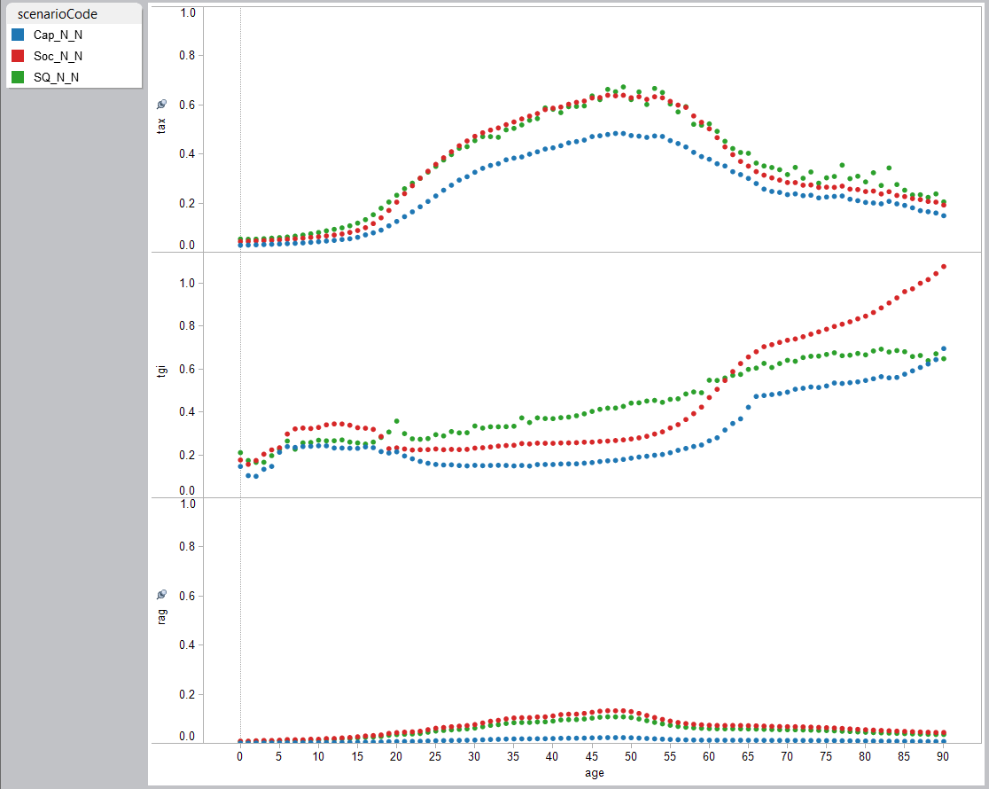

The share of GDP devoted to public transfer inflows and taxes are reported for four scenarios in Figure 8. In addition to the three scenarios described above we consider a fourth scenario – the social welfare scenario constrained to insure that public transfer inflows do not exceed 45 percent of GDP and that public debt does not exceed 90 percent of GDP. Above the 45-degree line in the figure taxes exceed spending on public transfer inflows. Below the 45-degree line indicates a public transfer deficit – taxes are less than spending on public transfer inflows.

Two of the scenarios are entirely unsustainable in the long run and point to the impossibility of either the status quo or the social welfare options given population aging. But even under these scenarios, significant gaps between tax revenues and public transfer inflows do not emerge until after 2035. Promises for generous support to the elderly can be made and can be met for a while. But eventually, those promises would have to be broken with potentially devastating effects. The constrained scenario shows the implications of adopting the social welfare approach which targets more support the elderly but doesn’t deal with the public finance problem. Under this scenario, the size of government constraint abruptly binds beginning in 2050. Spending on public transfer inflows is held at 45 percent of GDP as compared with eventually exceeding 55 percent of GDP given unconstrained growth. Even earlier the debt constraint is pushing taxes higher as can be seen be comparing the constrained and unconstrained social welfare reform scenarios. Taxes are raised steadily higher reaching 48 percent of GDP at the end of the scenario in 2100. In the absence of tax increases, mounting deficits would have led to very large public debt – more than twice GDP in 2065 and more than 4 times GDP in 2075.

Figure 8. Public transfer inflows (TGI) and taxes (TAX) as a share of GDP, Brazil, 1996 to 2100, four scenarios: status quo (SQ), capitalistic (Cap), social welfare (Soc) and social welfare with constraint that public transfer inflows cannot exceed 45% of GDP and public debt cannot exceed 90% of GDP.

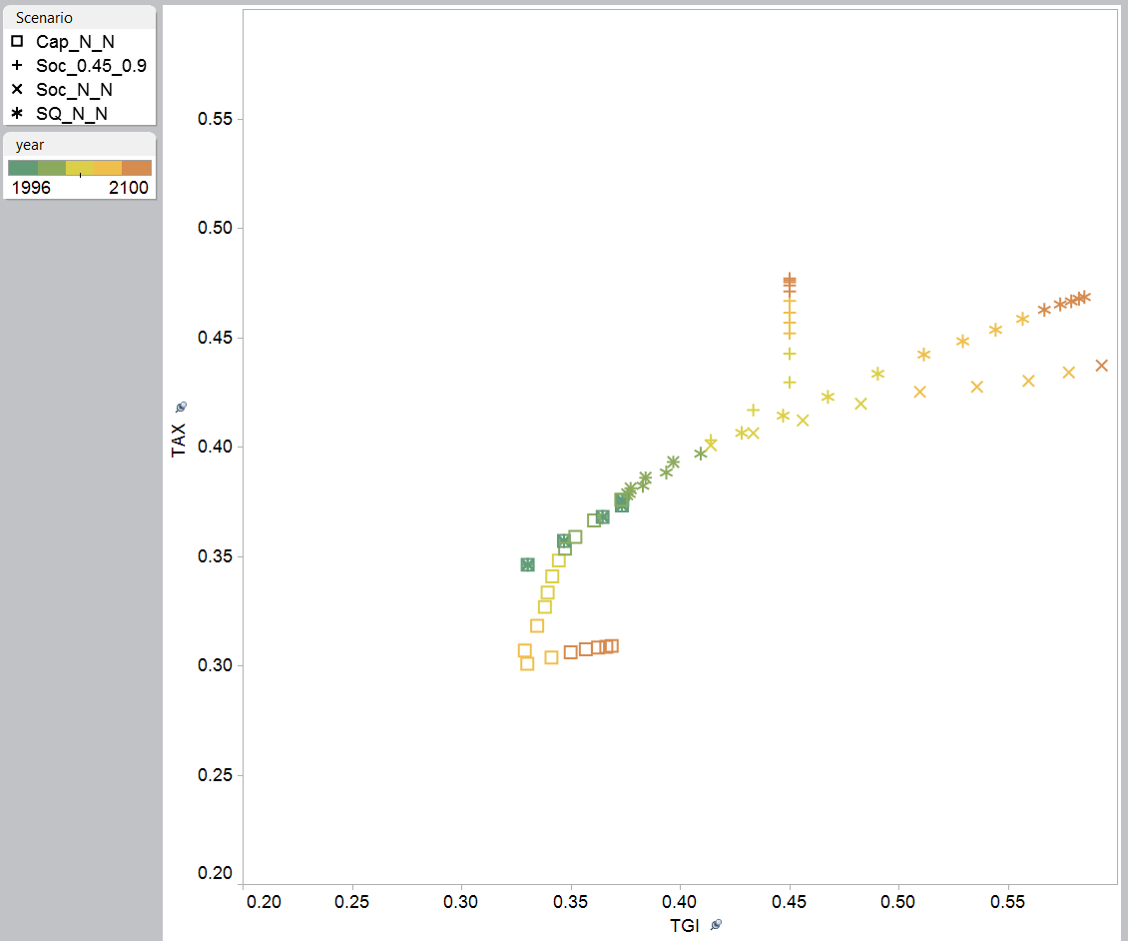

Taxes < public transfer inflows

2100

1996

2010

2080

2100

2100

Taxes > public transfer inflows

The capitalistic scenario is a radical departure from the status quo scenario. Starting in 2020 both taxes and public transfer inflows are reduced. By 2035 both are about 35 percent of GDP with public transfer inflows slightly higher than tax revenues. Reform leads to further declines in public transfer inflows but taxes are declining more sharply under the influence of population aging. As a consequence spending exceeds taxes until eventually the capitalistic scenario leads to undesirable debt levels. By 2075 net public debt would reach 80 percent of GDP and by 2080 120 percent of GDP. The capitalistic scenario is not sustainable in the very long run given the anticipated extent of population aging in Brazil.

**6. Summary**

In this study, we examined intergenerational public transfers in Brazil between 1996 and 2011. The results suggest that the distinct pattern of public transfers described for 1996 in earlier studies, and characterized by relatively larger transfers to the elderly, has remained strong over the last decades, although changed to some extent in favor of children more recently. Larger per capita investments in the younger age groups, mainly through increasing inflows of public education and other transfers, mitigated the unequal distribution of net transfers between children and the elderly. However, aggregate expenditures with the elderly also increased, because of population aging, and thus, Brazil remained an exception when compared to the distribution of public transfers in other countries. Persistent benefit patterns for the elderly and higher transfers to children lead to an additional tax burden on the working age groups.

The resilience of the age pattern of public transfers in Brazil is certainly one of the big challenges for fixing the current fiscal situation and impose several challenges for the future, as population aging will continue. This unusual distribution of resources among dependent age groups is the result of permissive social security rules, generous benefits for public servants, low ages at retirement, legislation regarding public expenditures, as well as population aging (Rangel and Caetano, 2015; Almeida, 2015; Pessoa, 2015). However, as we have argued elsewhere (Turra et al 2011), it also reflects an historical compensation for decades of underinvestment in human capital in addition to hostile working conditions that avoided members of numerous cohorts from saving for retirement, increasing poverty risk at older ages.

The case of Brazil is peculiar because of the simultaneous expansion of public transfers to children and elderly, mostly after the 1980s. The much lower proportion of elderly in the population and the growing share of the working-age groups at that time have certainly facilitated the expansion of the social programs. At least since late 1970s, demographers knew that population aging would happen fast in Brazil, but obviously, it has been difficult to convince policy makers with demographic projections that go thirty or fifty years into the future.

The recent increases in public transfers on education have helped reduce inequality across age and social groups. However, fixing the unbalanced ratio of net public transfers across age groups in Brazil by simply expanding further public expenditures with the youth, without reforming social security, is probably economically inefficient and impossible under the current economic and demographic contexts. Policies that lead to improvements in the quality of primary and secondary education, and that target the expansion of subsidized tertiary education to lower SES groups should be the goals for the next years. The declining number of children and youth in the decades to come represent an opportunity for the implementation of such policies. At the same time, we need to fix social security to make it a sustainable social insurance program for future generations, for example, by implementing a minimum age at retirement. The expansion of social security benefits to the poor after 1988 played an important social role, but the educational, occupational and health profile of the new cohorts have been changing substantially and the eligibility rules should reflect those changes.

**7. References**

Almeida, I.C. (2001). Gastos com educação no período de 1994 a 1999. Revista Brasileira de Estudos Pedagógicos. Brasilia, v.82.

Almeida, M. (2015). A Rigidez do Gasto Público: Problemas e Soluções. Revista Interesse Nacional – Ano 8, número 31, outubro-dezembro de 2015

Ansiliero, G., & Paiva, L. H. (2008). The recent evolution of social security coverage in Brazil. *International Social Security Review*, *61*(3), 1-28.

Araujo, Tatiana; Turra, C.M.; Queiroz, B.L. (2010) "Equidad intergeneracional en el Brasil: transferencias de seguridad social y educación pública entre generaciones nacidas en el período 1923-2000." *Notas de Población*.

Aureliano, L. M., & Draibe, S. M. (1989). A especificidade do Welfare State brasileiro. *En: Reflexões sobre a natureza do bem-estar-LC/BRS/L. 9-1989-p. 86-178*.

Barrientos, A., Møller, V., Saboia, J., Lloyd-Sherlock, P., & Mase, J. (2013). ‘Growing’ social protection in developing countries: Lessons from Brazil and South Africa. *Development Southern Africa*, *30*(1), 54-68.

Camargo, J. M. (2003). Gastos sociais: focalizar versus universalizar. *Políticas Sociais–acompanhamento e análise*, (7).

Camargo, J. M. (2004). Política social no Brasil: prioridades erradas, incentivos perversos. *São Paulo em perspectiva*, *18*(2), 68-77.

Carvalho, G. (2013). Gasto público em Saúde, Brasil. Instituto Brasileiro de Saúde, Ensino, Pesquisa e Extensão para o Desenvolvimento Humano.

Castro, J. A. D. C., Ribeiro, J. A. C. C., Chaves, J. V. C., & Duarte, B. C. C. (2011). 15 anos de Gasto Social Federal: notas sobre o período de 1995 a 2009.

Corbucci, P. R. (2014). Evolução do acesso de jovens à educação superior no Brasil. Textos para Discussão (1950), IPEA, Brasília, DF.

Costanzi, R. N., & Ansiliero, G. (2014). Evolução recente e alguns determinantes da proteção social dos idosos na América Latina e no Brasil. *Revista do Serviço Público*, *60*(3), 219-240.

Dataprev (2015). Aeps Infologo. Base de Dados Históricos da Previdencia Social. Ministério da Previdencia Social. http://www3.dataprev.gov.br/infologo/

Datasus (2015). Sistema de informações sobre orçamentos públicos em saúde (SIOPS). Ministerio da Saude. Brasilia. http://portalsaude.saude.gov.br/

Filgueira, F. (2005). Welfare and democracy in Latin America: the development, crises and aftermath of universal, dual and exclusionary social states. *Prepared for the United Nations Research Institute for Social Development Project on Social Policy and Democratization, New York*.

Gruber, J., & Wise, D. A. (2002). An International Perspective on Policies for an Aging Society. *Policies for an Aging Society*, 34.

Gragnolati, M; Jorgensen, O. H., Rocha, R., & Fruttero, A. (2011). *Growing old in an older Brazil: implications of population aging on growth, poverty, public finance and service delivery*. World Bank Publications.

INEP (2015). Informações Estatísticas. Investimentos públicos em educação. Instituto Nacional de Estudos e Pesquisas Educacionais Anísio Teixeira http://portal.inep.gov.br/estatisticas-gastoseducacao.

IPEADATA (2015). Instituto de pesquisa econômica aplicada. http://www.ipeadata.gov.br/

Lavinas, L. (2007). Gasto social no Brasil: programas de transferência de renda versus investimento social. *Ciência & Saúde Coletiva*, *12*(6), 1463-1476.

Lavinas, L., & Garson, S. (2003). Gasto Social no Brasil: Transparencia, sim, parti-pris, não!. *Econômica*, *5*(1), 145-162.

MDS (2015). Ministerio do Desenvolvimento Social. http://www.brasil.gov.br/cidadania-e-justica/2012/10/bolsa-familia-completa-nove-anos-e-beneficia-13-7-milhoes-de-familias/bolsa-familia-9-anos/view

Pessoa, S. (2015). Esgotamento Fiscal: por que somente agora? Revista Interesse Nacional – Ano 8, número 31, outubro-dezembro de 2015

Queiroz, B. L. & Figoli, M. (2014). "Population Aging and the Rising Costs of Public Pension in Brazi". In: Reilly, T. (ed) Pensions: Policies, New Reforms and Current Challenges. Happauge, New York: Nova Science Publishers.

Rangel, L. A. C., & Caetano, M. A. R. C. (2015). Previdência social.

Rios-Neto, E. L. G. (2005). Questões emergentes na análise demográfica: o caso brasileiro. *Revista Brasileira de Estudos de População, São Paulo*, *22*(2), 371-408.

Santos, C.H.M., Gouvea, R.R., Leal, E.M., Leão, I.D.S. (2014). Estimativas trimestrais das transferências públicas de assistência e previdência no Brasil (1995-2012). Economia Aplicada, v.18, n.3, p.543-573.

Silveira, F. G., Mostafa, J., Caetano, M. A. R., & Santos, M. P. G. D. (2011). Previdência dos servidores públicos: reflexões em torno da proposta de instituição da previdência complementar. Textos para Discussão (1679), IPEA, Brasília, DF.

Soares, A., & Santos, N. R. D. (2014). Financiamento do Sistema Único de Saúde nos governos FHC, Lula e Dilma. *Saúde debate*, *38*(100), 18-25.

Soares, S. S. D. (2012). *Bolsa Família, its design, its impacts and possibilities for the future* (No. 89). Working Paper, International Policy Centre for Inclusive Growth.

Turra, C. M. (2000). *Contabilidade das Geracoes:* riqueza, sistema de transferencias e consequencias de mudancas no padrao demografico. Master's thesis, CEDEPLAR/UFMG, 2000.

Turra, C.M. & Queiroz, B.L. (2005) Intergenerational transfers and socioeconomic inequality in Brazil: A first look. Taller sobre Transformaciones Demograficas, Transferencias Intergeneracionales y Proteccion Social en America Latina. Santiago, Chile, Celade, 6 a 7 de julho 2005a.

Turra, C. M., & Queiroz, B. L. (2005b). Before it's too late: demographic transition, labor supply, and social security problems in Brazil. In *United Nations Expert Group Meeting on Social and Economic Implications of Changing Population Age Structures*.

Turra, C.M.; Queiroz, B.L.; Rios-Neto, E.L.G. (2011). Idiosyncrasies of intergenerational transfers in Brazil. In: Population Aging and Generational Economy: A Global Perspective, Ronald Lee and Andrew Mason (editors).

Wong, L. L. R., & Carvalho, J. A. (2006). O rápido processo de envelhecimento populacional do Brasil: sérios desafios para as políticas públicas. *Rev Bras Estud Popul*, *23*(1), 5-26.

1. This paper is part of the NTA/World Bank project: Aging and the Changing Nature of Intergenerational Flows in Developing Countries.
2. We use population estimates by age prepared by the United Nations Population Division (UN 2015).
3. Caution is required when reading the graphs since we use different scales for the various public programs.
4. The age profile of public asset-based reallocations for the base year is not available. The profile used here is based on the shape of the tax profiles and is a close approximation of the actual age profile for the base year.